Q1 Install Power BI Desktop and share the final screenshot of the report view pagewhich appears when power desktop starts.

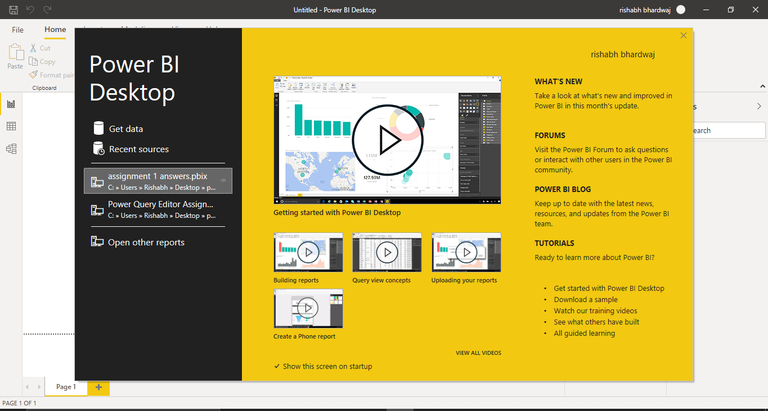

Q2 Prepare a document and with the following screenshot- Report View

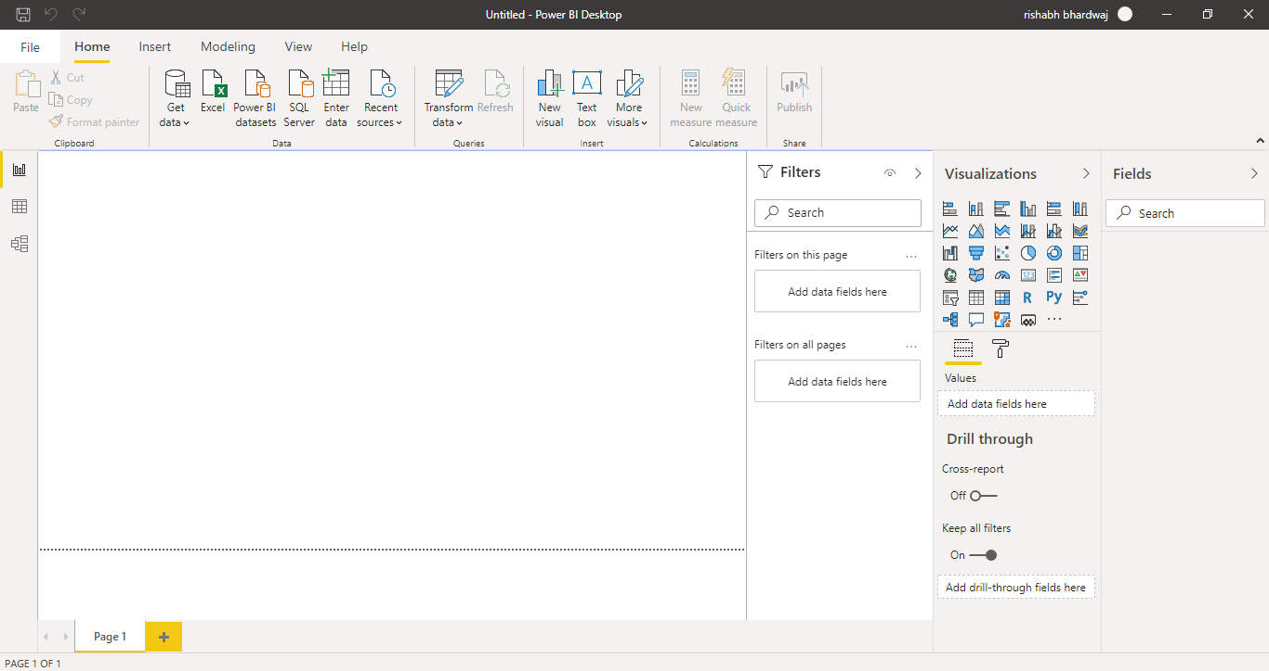

- Data View

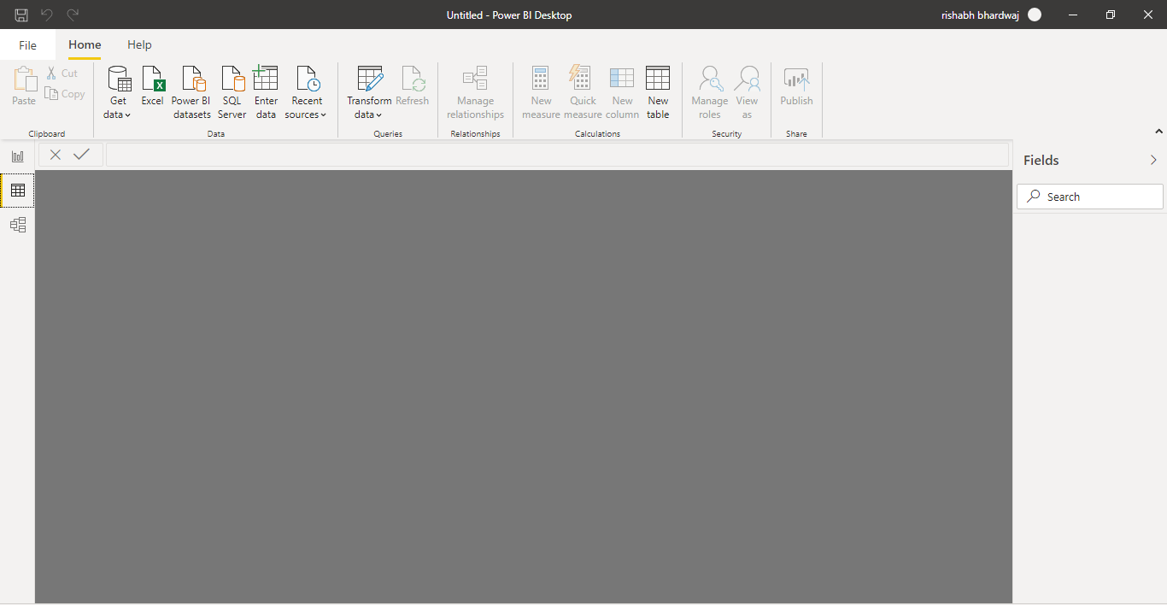

- Model View

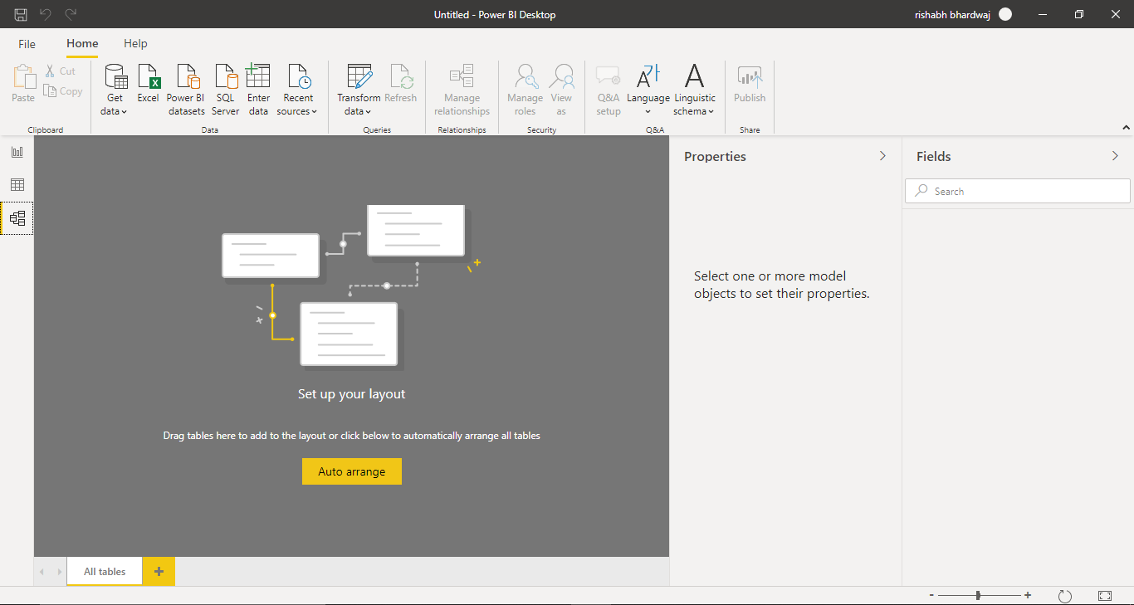

- Power Query Editor

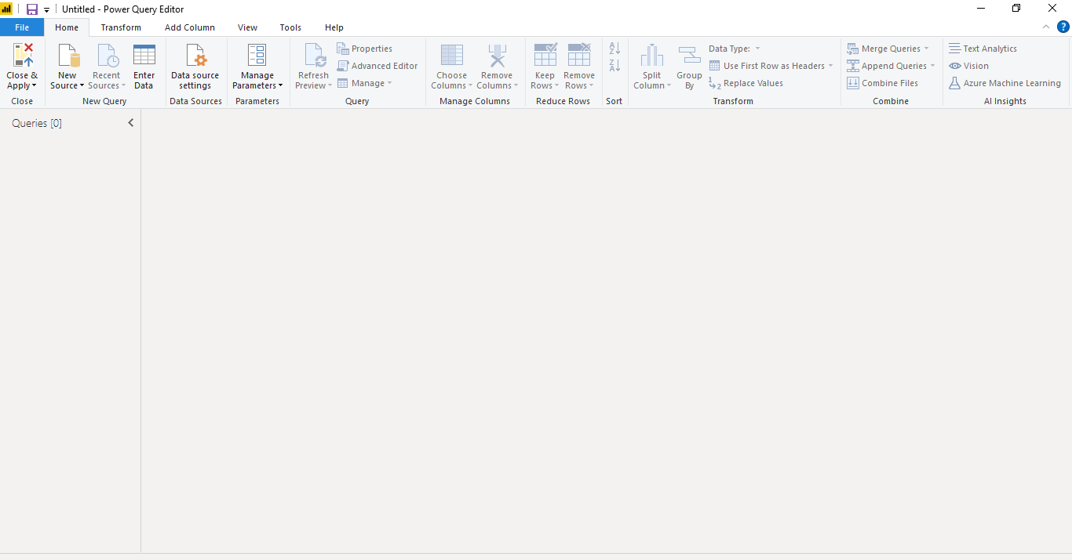

- Advance Editor

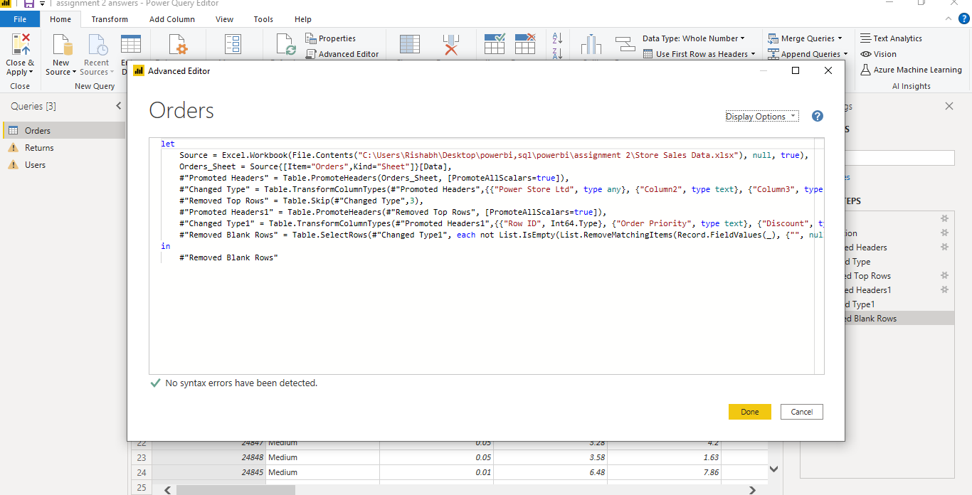

*Q3* **Prepare a document with details of the following along with their price**- ***Power BI Desktop=***

**Power BI Desktop** is a free application you install on your local computer that lets you connect to, transform, and visualize your data

- ***Power BI Pro****=*

Self-service and modern BI in the cloud

Collaboration, publishing, sharing, and ad-hoc analysis

Fully managed by Microsoft

**Power BI Pro**

**$9.99** Monthly price per user

**- *Power BI Premium=***

Enterprise BI, big data analytics, cloud and on-premises reporting

Advanced administration and deployment controls

Dedicated cloud compute and storage resources

Allows any user to consume Power BI content

Power BI Premium

**$4,995** Monthly price per dedicated cloud compute